1. How much interest is earned on a Principal of $4000, invested at a rate of 6% per annum for a term of 5 years?

2. A washing machine costs $700. If it is paid off over three years at 15% per annum simple interest, how much interest is paid?

3. Calculate the area.
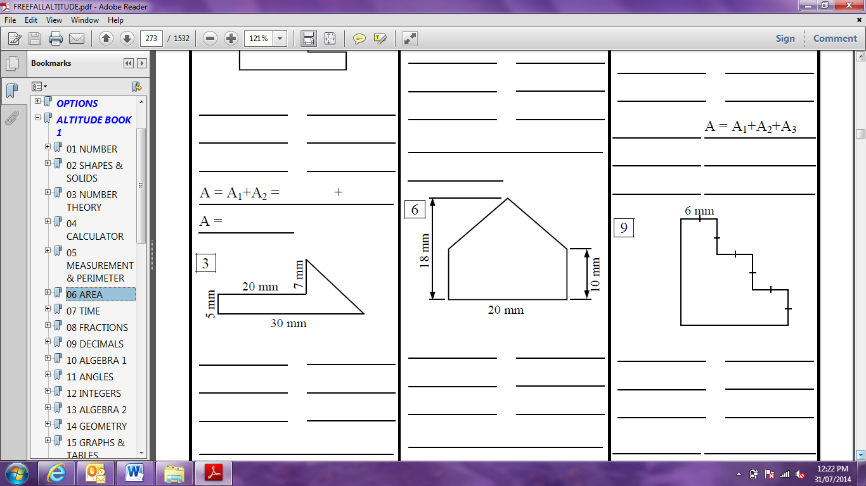

4. Calculate the surface area
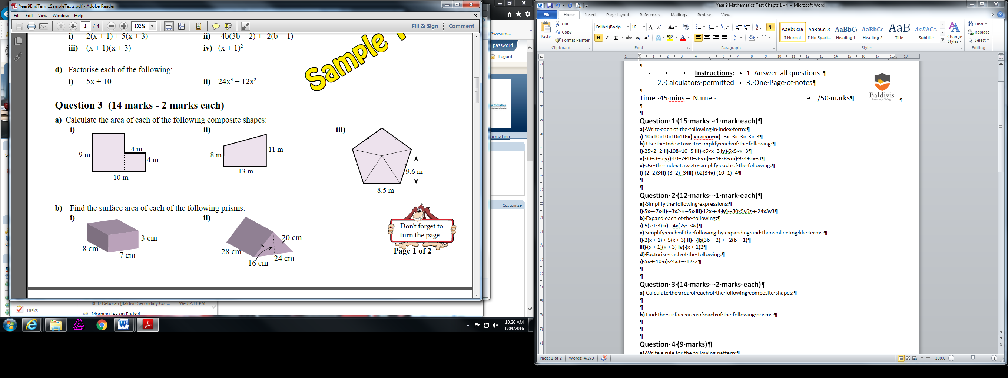

5. Simplify the following:

a 2⁷ x 2³ b $7^{4 }÷ 7^{3}$

c ${(2^{3})}^{4}$ d.
6. Simplify the following:

a. 6$ab$³ x 5$a$²$b$⁶

b ($n$³)² x (2$n$³)³

c . $\frac{p^{6}q^{8}}{p^{3}q}$

7. Simplify by collecting like terms:

3x+2x+5-4x+2x²

8. Expand:

$$2x\left(2x+3\right)$$

$$\left(x+5\right)\left(2x-2\right)$$

9. Factorise:

14x³+6x²+2x

